+
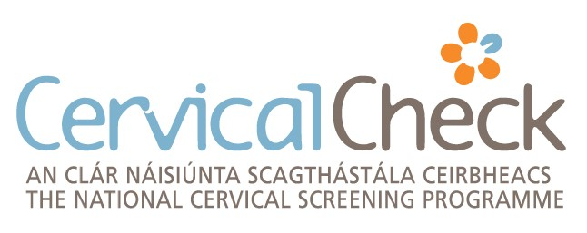
Registration Form Health Professionals
Health Professionals referred to as Qualified Persons include GPs, GP Registrars, Registered Nurses on the General Nurse Division or Midwives Division of the Nurse and Midwifery Board of Ireland (NMBI) Register. Please use a single sheet for each person.
The Qualified Person acknowledges and agrees that Programme cervical screening tests will be carried out under the clinical responsibility of the General Practitioner (GP) below. This is pursuant to the Contract for the provision of cervical screening services as part of the National Cervical Screening Programme entered into by the GP and the National Screening Service. The contracted GP shall receive payment for all such tests carried out.
_ _ _ _

Health Professional

Name of doctor or nurse
(BLOCK CAPITALS) Male Female

Please specify GP GP Registrar Registered General Nurse Registered Midwife

Medical Council Registration Number (MCRN) or Nursing & Midwifery Board of Ireland number (NMBI)

I have completed the ‘CervicalCheck in Practice’ online Introductory eLearning module Yes
Mandatory for new registrations with effect from 01/09/2022
For existing registrations mandatory from 01/09/2023

Personal Email address

I consent to the use of this email for administrative communications from CervicalCheck Yes No
(Administrative communications will include information on policy updates, study days, newsletters etc)

Signature of the Doctor / Nurse Date

_ _ _ _

Clinically Responsible General Practitioner (Contracted GP)

Name (BLOCK CAPITALS)

Medical Council Registration Number (MCRN)

PCERS (GMS) Number

Signature of Clinically Responsible GP Date

The QP and the Clinically Responsible General Practitioner will be notified when the registration process has been completed.
It is important to notify Programme Administration Office of any changes to your details or professional registration status.
_ _ _ _
For office use only

Date stamp

Check 1 Date

Check 2 Date

Practice ID

CS/F/A-8 Rev 13
PO Box 161, Limerick.

Phone: 061 406500
Cuid d’Fheidhmeannacht na Seirbhíse Sláinte. Part of the Health Service Executive. Email: admin@cervicalcheck.ie www.cervicalcheck.ie

